**Wet 2**

**Yagel Maimon**

**Saar Gablinger**

**Q1.** 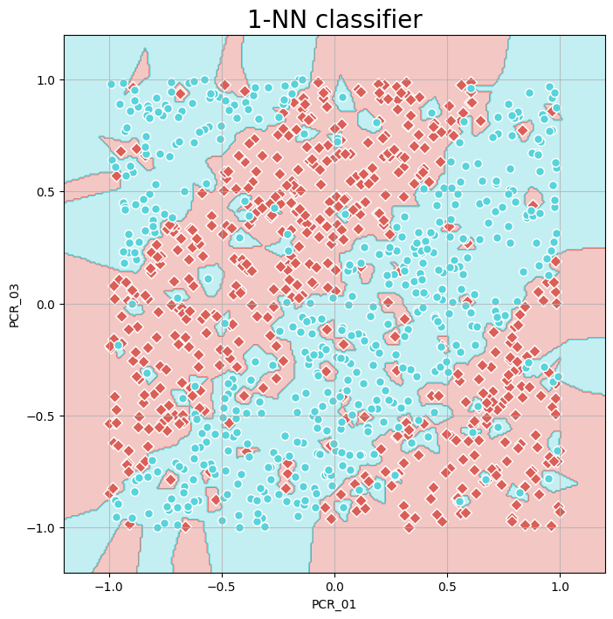

The best k value is 9

Mean train score: 1.0

mean Validation score: 0.869

by the figure The k values that cause overfitting is about from 1 to 5 because this is the lowest k values that make the training accuracy be the much highest and we can see that in those numbers the difference between the validation accuracy and the training accuracy is the biggest. and the k values that cause underfitting is about 130 and above that’s happends because we look at too many neighbors and from 130 k we can see that the accuracy is lower then 0.7 and get lower exponential when we go forther.

Q3.

And the tests accuracy is 0.8

Q4.

In Q1 we can see that because of the overfitting the bounderies looks dissaster and its not smooth like the bounderies in k=9 because the in k=9 we look at the best number of neighbors that will make the training look good.

Q5.